**Segmentation for Medical**

**Market in India of bio tech Startup**

**SERVICE:-**

**1. Body checkup with blood sample with online offering.**

**2. Device:- diabetes, blood pressure, vitamin deficiency checkup.**

**What is market segmentation?**

Well to be concise and clear market segmentation is the delineation or disaggregation of the marketinto uniquely distinct submarkets.Benefits of Market Segmentation in healthcare Market segmentation is a decision-making tool for the marketing manager in the crucial task of selecting a target market. In the Healthcare industry, a company willing to offer different services to different target audiences will lead to the sustainable growth of the company. Customers would get what they are seeking and the company would emerge as the best possible service provider.Deploying an appropriate market segmentation strategy will also provide competitive advantage over other similar companies.

**Problem Statement**

In this report, our goal is to gather information about the present health care market in India and to obtain detailed knowledge about some of the specifics like online health service appointment bookings from various states and also parts of those states and customers from which region of India are willing to use smart devices for monitoring their vitals like Diabetes level, Blood Pressure and vitamin deficiencies. This will be done using analytical methods and market segmentation to draw out segments using the limited amount of data obtained from several trusted platforms, including government open source. We have to analyse Medical Market in India with respect to the given problem statement using Segmentation analysis and come up with a feasible strategy to enter the market

**Fermi Estimation**

A Fermi estimate is one done using back-of-the-envelope calculations and rough generalisations to estimate values which would require extensive analysis or experimentation to determine exactly. Fermi estimates generally work because the estimations of the individual terms are often close to correct, and overestimates and underestimates help cancel each other out. That is, if there is no consistent bias, a Fermi calculation that involves the multiplication of several estimated factors will probably be more accurate than might be first supposed. Although Fermi calculations are often not accurate, as there may be many problems with their assumptions, this sort of analysis does tell us what to look for to get a better answer.

**Dataset1:- Disease burden estimates**

* Diarrheal and mental disease are most common.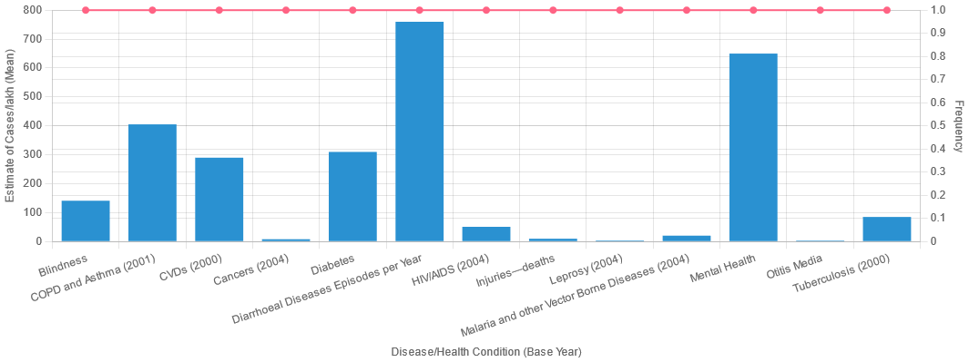

**Dataset2:- Internet user**

* This startup is online so we need to know the user in state how many users are using the internet.
* Men:- Lakshadweep goa and mizoram.
* Women:- Goa, Sikkim, and mizoram.

**Dataset:- Number of hospitals**

* Startup competitors are small businesses and hospitals.
* Delhi NCR has many hospitals.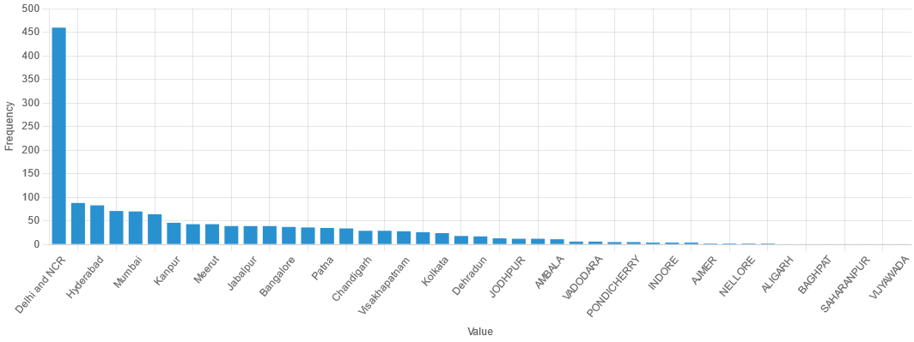

**Dataset4:- Literacy rate**

* Kerala, Lakshadweep and Mizoram has high literacy rates.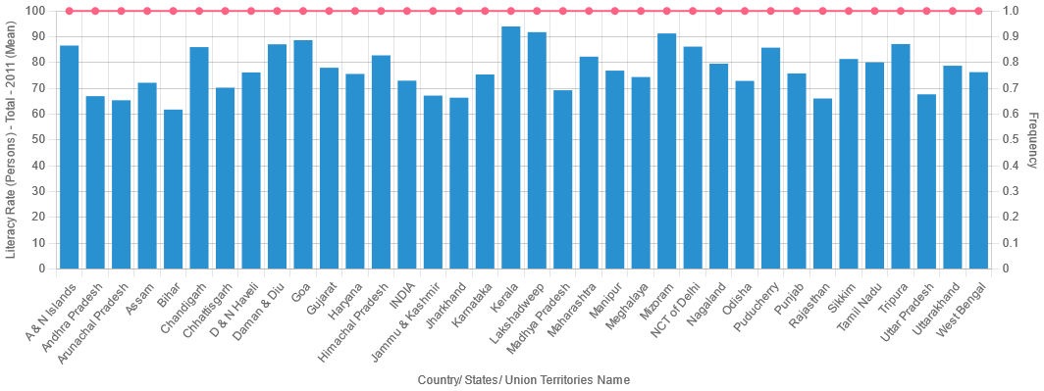

**Dataset5:- Population in state**

* Uttarpradesh, Bihar and Maharashtra have high populations.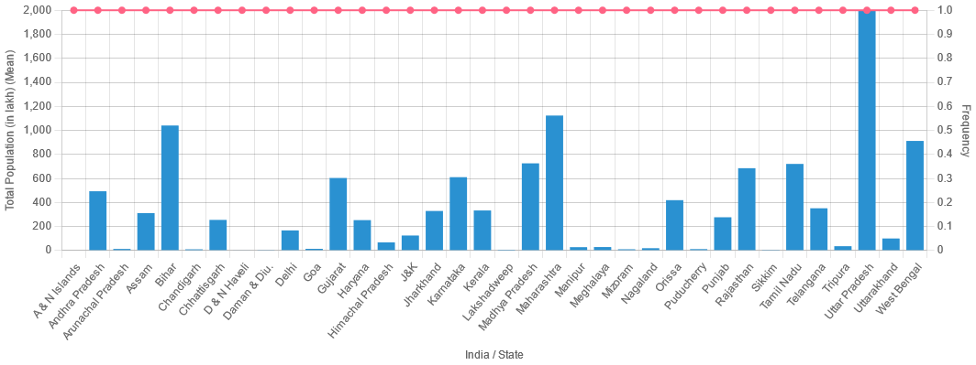

**Dataset6:- Doctors in state**

* Andhra Pradesh has many doctors.

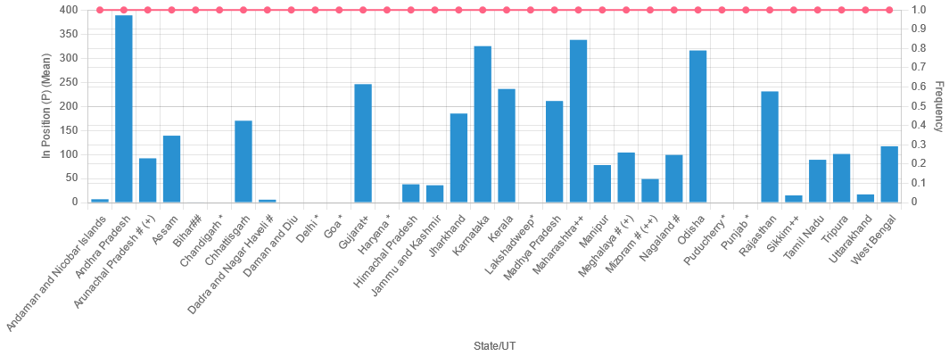

**Dataset7:- State with some disease(diabetes, asthma, goitre/thyroid, heart disease and cancer)**

* Women diabetes:- Andaman nicobar island, kerala, tamil nadu, goa and lakshadweep.
* Women Asthma:- Andaman nicobar island, tripura, tamil nadu, telangana and west bengal.
* Women Goitre or any other Thyroid Disorder :- kerala, jammu kashmir, chandigarh, lakshadweep and telangana.
* Women Any heart disease:- jammu and kashmir, meghalaya, mizoram, tripura and manipur.
* Women cancer:- Bihar, meghalaya, tamil nadu, karnataka and mizoram.
* Men Diabetes:- kerala, meghalaya, andhra pradesh and tamil nadu.
* Men asthama:- tamil nadu, odisha , nagaland, west bengal.
* Men who have - Goitre or any other thyroid disorder:- Tamil nadu, meghalaya, jammu and kashmir, chandigarh and jharkhand.
* Men health disease:- lakshadweep, tripura, mizoram, jammu kashmir and tamil nadu.
* Men cancer:- Himachal pradesh, tamil nadu, jharkhand, andaman and nicobar island.
* ***Tamil nadu is a country that has almost all types of disease.***

**Dataset8:- State wise diabetes**

* - TARGET AGE > 45
  + 0 - 20 = 8%
  + 20 - 30 = 4%
  + 30 - 45 = 8%
  + 45 - 60 = 22%
  + 60 < - = 30%
* STATE:- kERALA, Tamil nadu, goa tripura, delhi west bengal
* Target men and urban area

**Dataset9:- Indian census**

**STEP 1:- Importing Libraries and Dataset**

* **Indian census dataset**

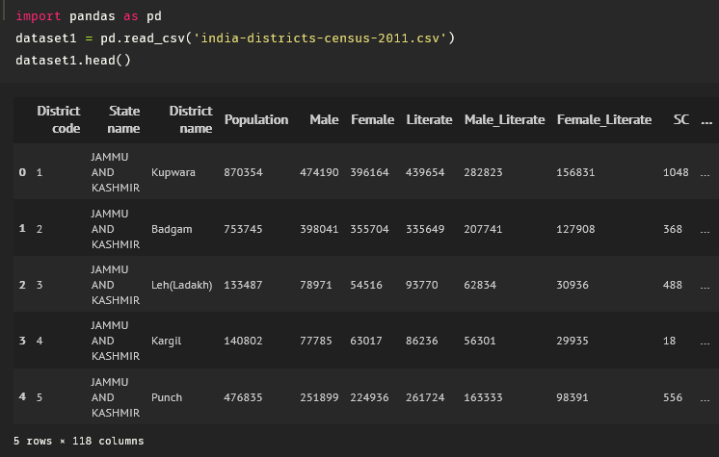

**STEP 2:- Simple Statistics**

* 640 rows and 180 columns.
* There are no missing values.

**STEP 3:- Delete unwanted column**

* Unwanted columns like religions, cast, category people, personal information like marriage or not, etc.

**STEP 4:- Analysis**

* **Population vs State**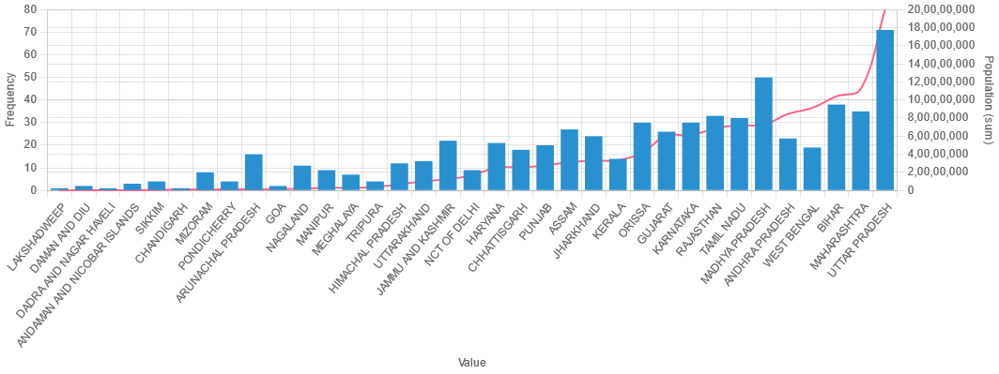UTTAR PRADESH, MADHYA PRADESH, BIHAR, MAHARASHTRA AND RAJASTHAN ARE GOOD STATES FOR STARTUP.
* **Literacy vs State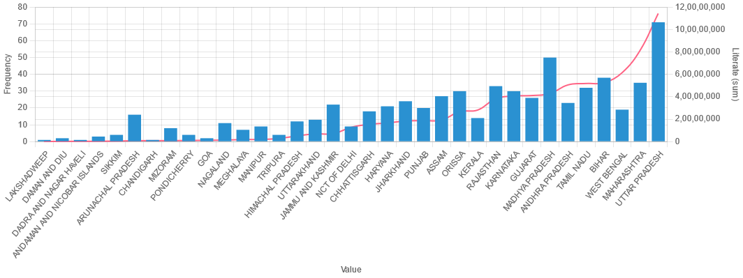**UTTAR PRADESH, MADHYA PRADESH, BIHAR, MAHARASHTRA AND RAJASTHAN HAS HIGH LITERACY STATES.
* **Internet vs State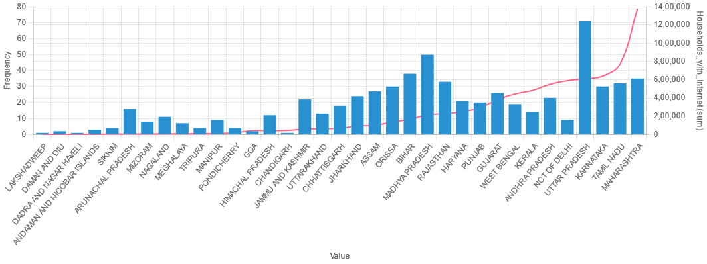**UTTAR PRADESH, MADHYA PRADESH, BIHAR, MAHARASHTRA AND RAJASTHAN HAS MANY INTERNET USERS.
* **Literacy with Population**